You shall not misuse the name of the LORD your God.
The name of the LORD is a strong tower;
the righteous run to it and are safe.
Proverbs 18:10
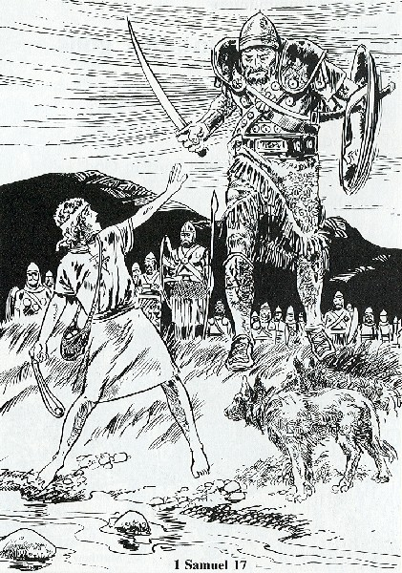

Many a terrible and shocking calamity would befall us if God did not preserve us through our calling upon his name.
I have tried it myself and learned by experience that often sudden, great calamity was averted and vanished in the very moment I called upon God.
To defy the devil, I say, we should always keep the holy name on our lips
so that he may not be able to injure us
as he is eager to do.
Luther's Large Catechism, 1,70

Read 1 Samuel 17
1. Compare Goliath to a modern day soldier. In what ways are they similar? Different?
2. How did the Israelite army misuse God's name?
3. What did Saul do to motivate the army?
4. How did Goliath misuse God's name?
5. How did David use God's name correctly?

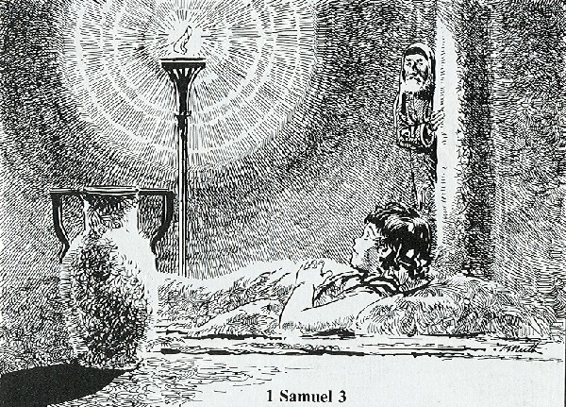

Read 1 Samuel 3
1. How did a boy end up ministering in the tabernacle with Eli?
2. What was Samuel's job?
3. Where was he when the LORD called him?
4. What message did the LORD give him?
5. What did Samuel tell Eli?
6. How did Samuel use God's name correctly?

Speak, O Lord, as we come to you
To receive the food of your Holy Word.
Take your truth, plant it deep in us;
Shape and fashion us in your likeness
That the light of Christ might be seen today
In our acts of love and our deeds of faith.
Speak, O Lord, and fulfill in us
All your purposes for your glory.
CWS 735

